

**Web Development Project Report phase 2**

**Course Title: CMPS 350**

**Submission Date: 11th may 2024**

**Team Members:**

1. Sidi Chaikh - 202104008
2. Ibrahim Mohamad Shatah - 201807372
3. Hassan Khan – 201908756

**Github Repository**

**https://github.com/sidi34308/capfa-website.git**

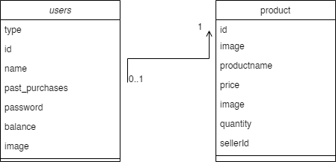

Database UML:

Entities UML:

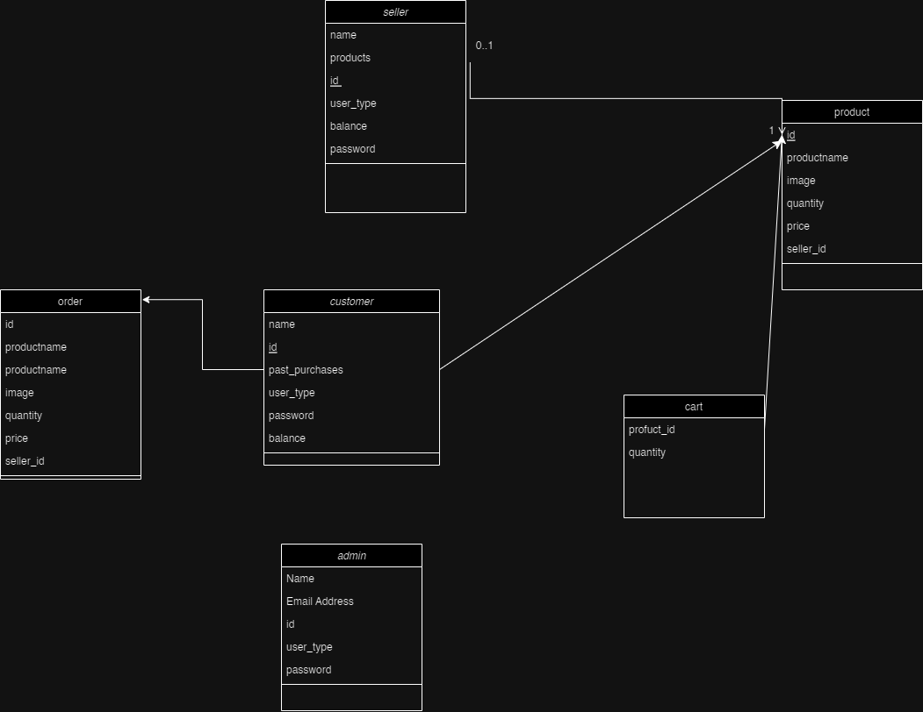

**Database queries**

import prisma from "../repo/prisma";

export async function getAllProducts() {

    return prisma.product.findMany({

        include: {

            seller: true,

        },

    });

}

export async function getProductById(id) {

    return prisma.product.findUnique({

        where: {

            id: id,

        },

        include: {

            seller: true,

        },

    });

}

export async function createProduct(data) {

    return prisma.product.create({

        data: data,

    });

}

export async function updateProduct(id, data) {

    return prisma.product.update({

        where: {

            id: id,

        },

        data: data,

    });

}

export async function deleteProduct(id) {

    return prisma.product.delete({

        where: {

            id: id,

        },

    });

}

import prisma from "../repo/prisma";

export async function getAllUsers() {

    return prisma.user.findMany();

}

export async function getUserById(id) {

    return prisma.user.findUnique({

        where: {

            id: parseInt(id),

        },

        include: {

            past_purchases: true,

        },

    });

}

export async function createUser(data) {

    return prisma.user.create({

        data: data,

    });

}

export async function updateUser(id, data) {

    return prisma.user.update({

        where: {

            id: parseInt(id),

        },

        data: data,

    });

}

export async function deleteUser(id) {

    return prisma.user.delete({

        where: {

            id: parseInt(id),

        },

    });

}

**Functionality**

Design and implement the Data Model : **DONE**

Init DB: populate the database with the data from the json files in seed.js : **DONE**

APIs and Repository Implementation to read/write data from the database: **DONE**

Statistics use-case with NextJS: **DONE**

Documentation - Data Model diagram. - UI Design with screenshots and description. - Database queries. - Conducted tests and evidence. - Contribution of each team member [-10pts if not done]: **DONE**

Design and implement the Data Model: **DONE**

**Screen Shots**

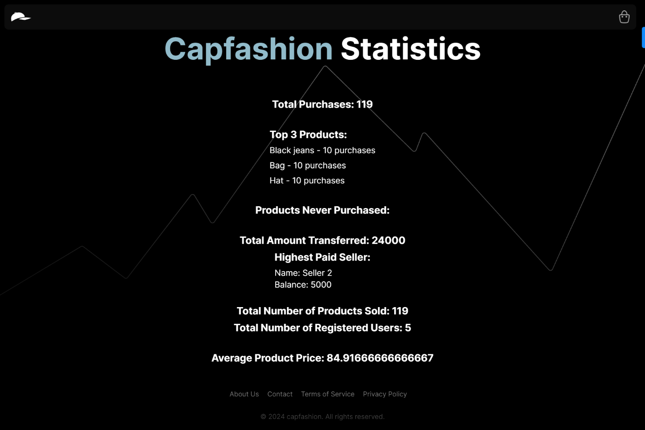

This Is the statistics page

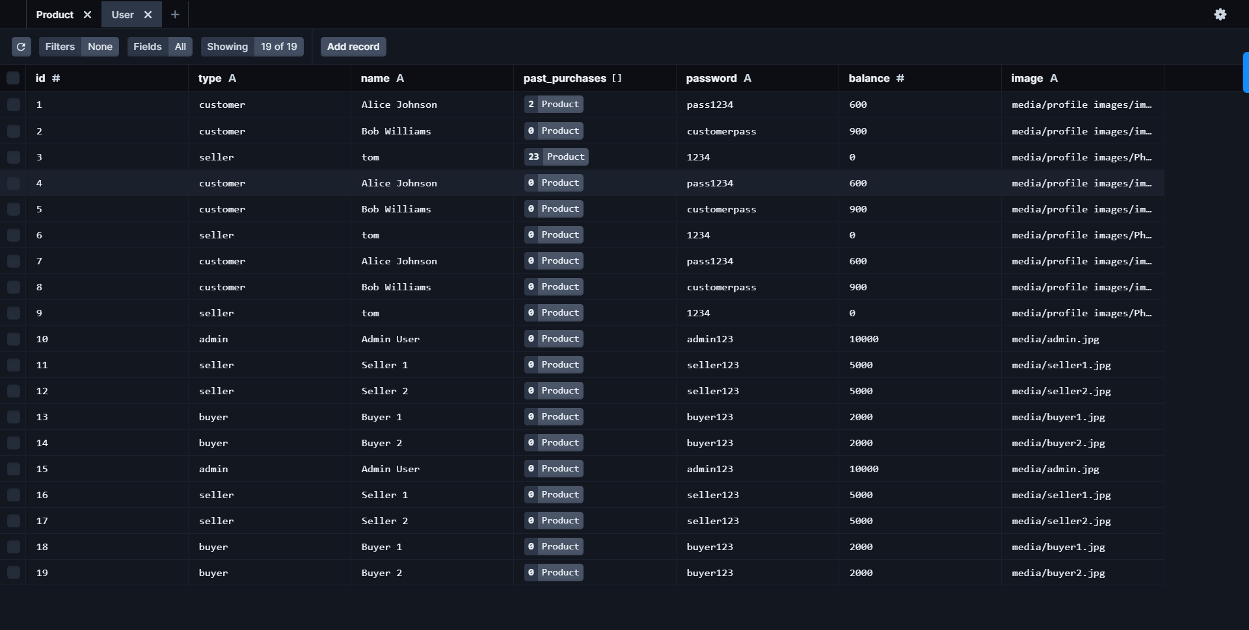users table in the database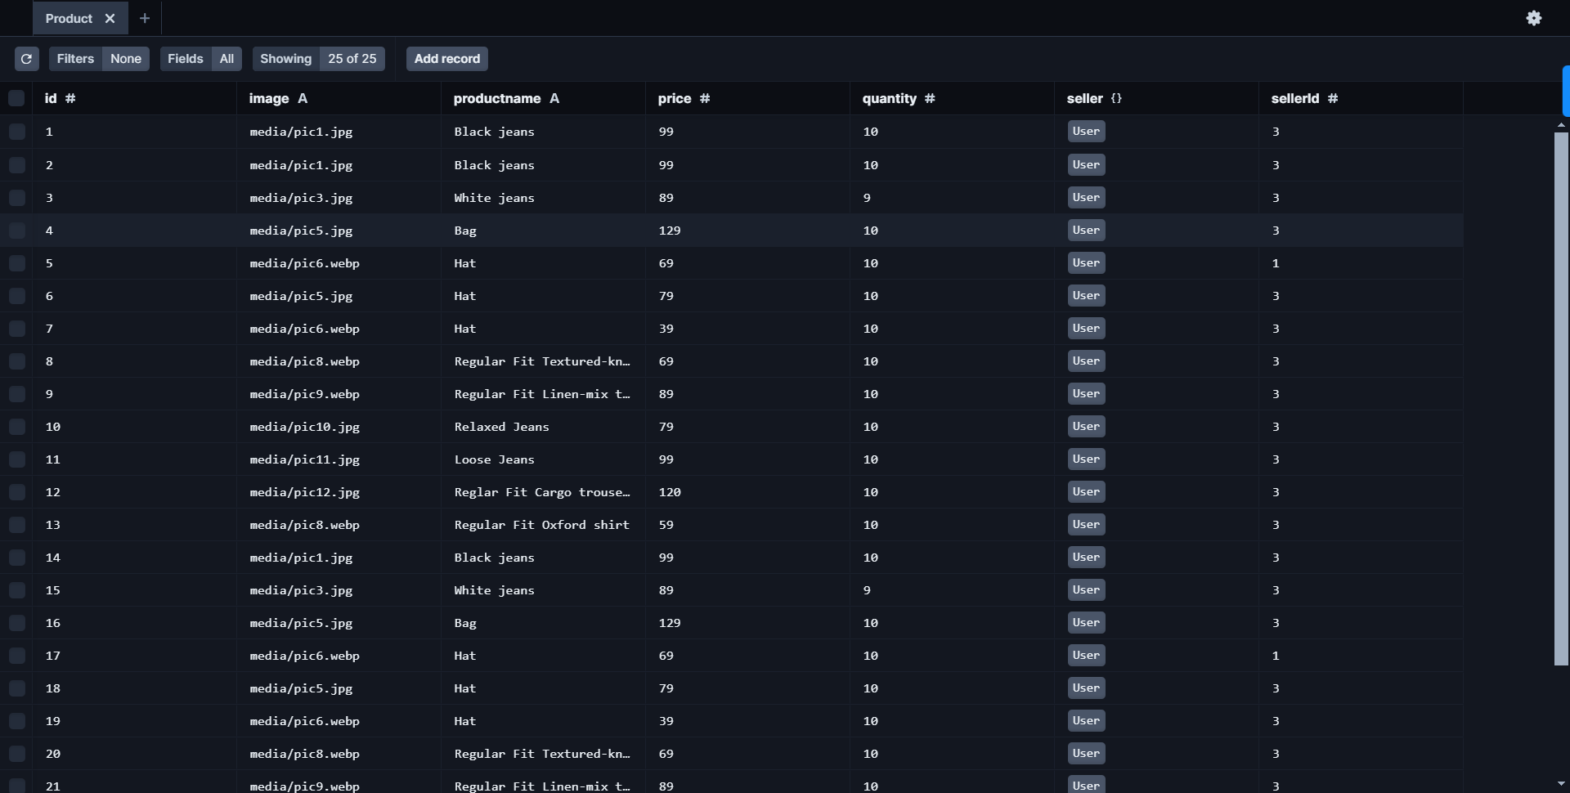 product table in the database

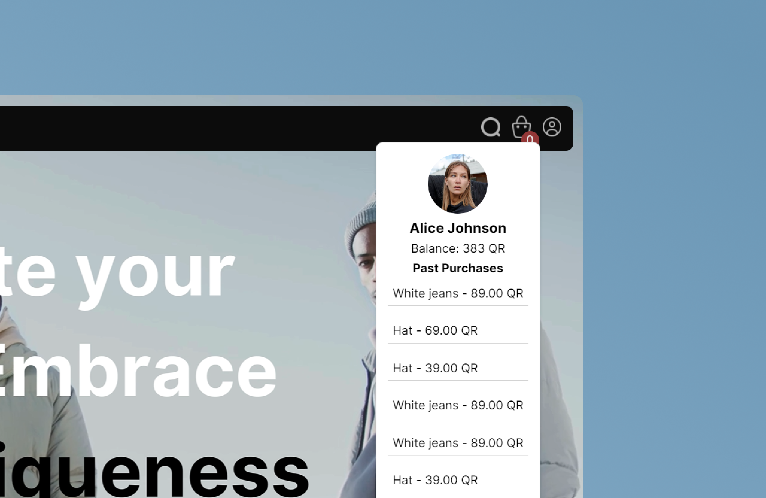

This images is screenshot of logged in user to our website

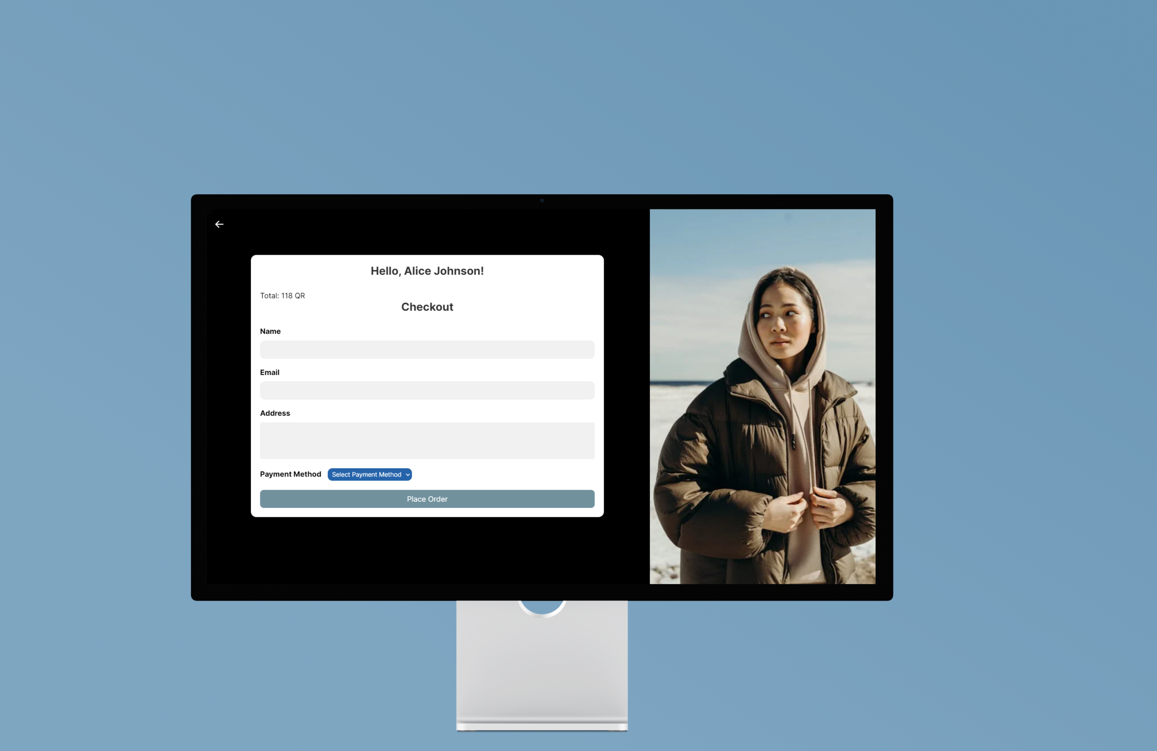

This screenshot is taking from the checkout page in the website

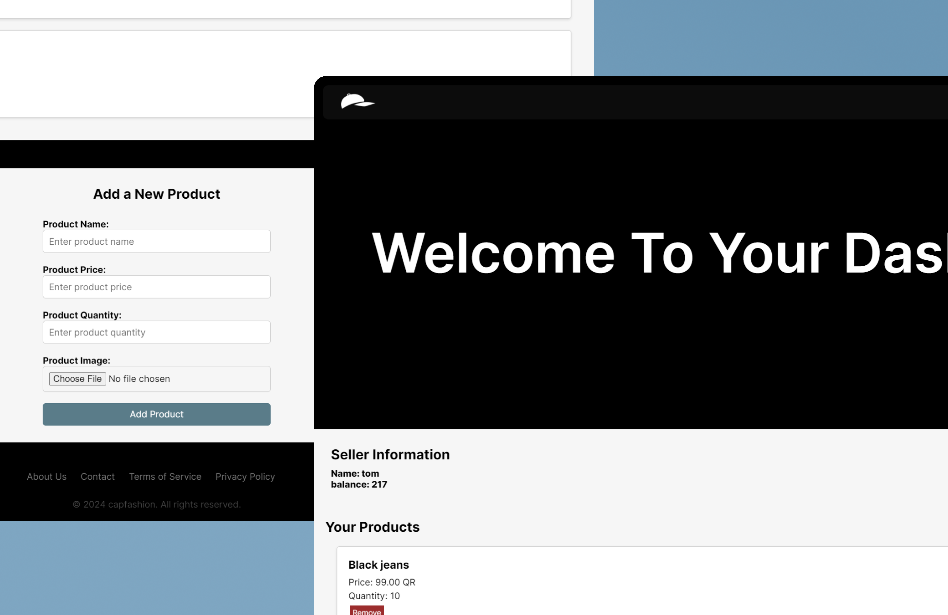

This screenshot is form the seller dashboard where s\he can publish new product and visualize his/her status

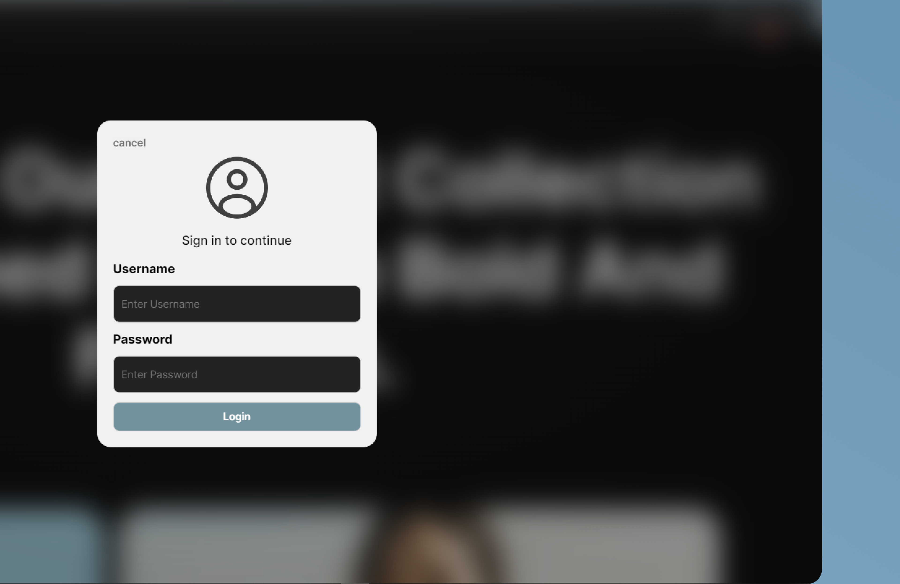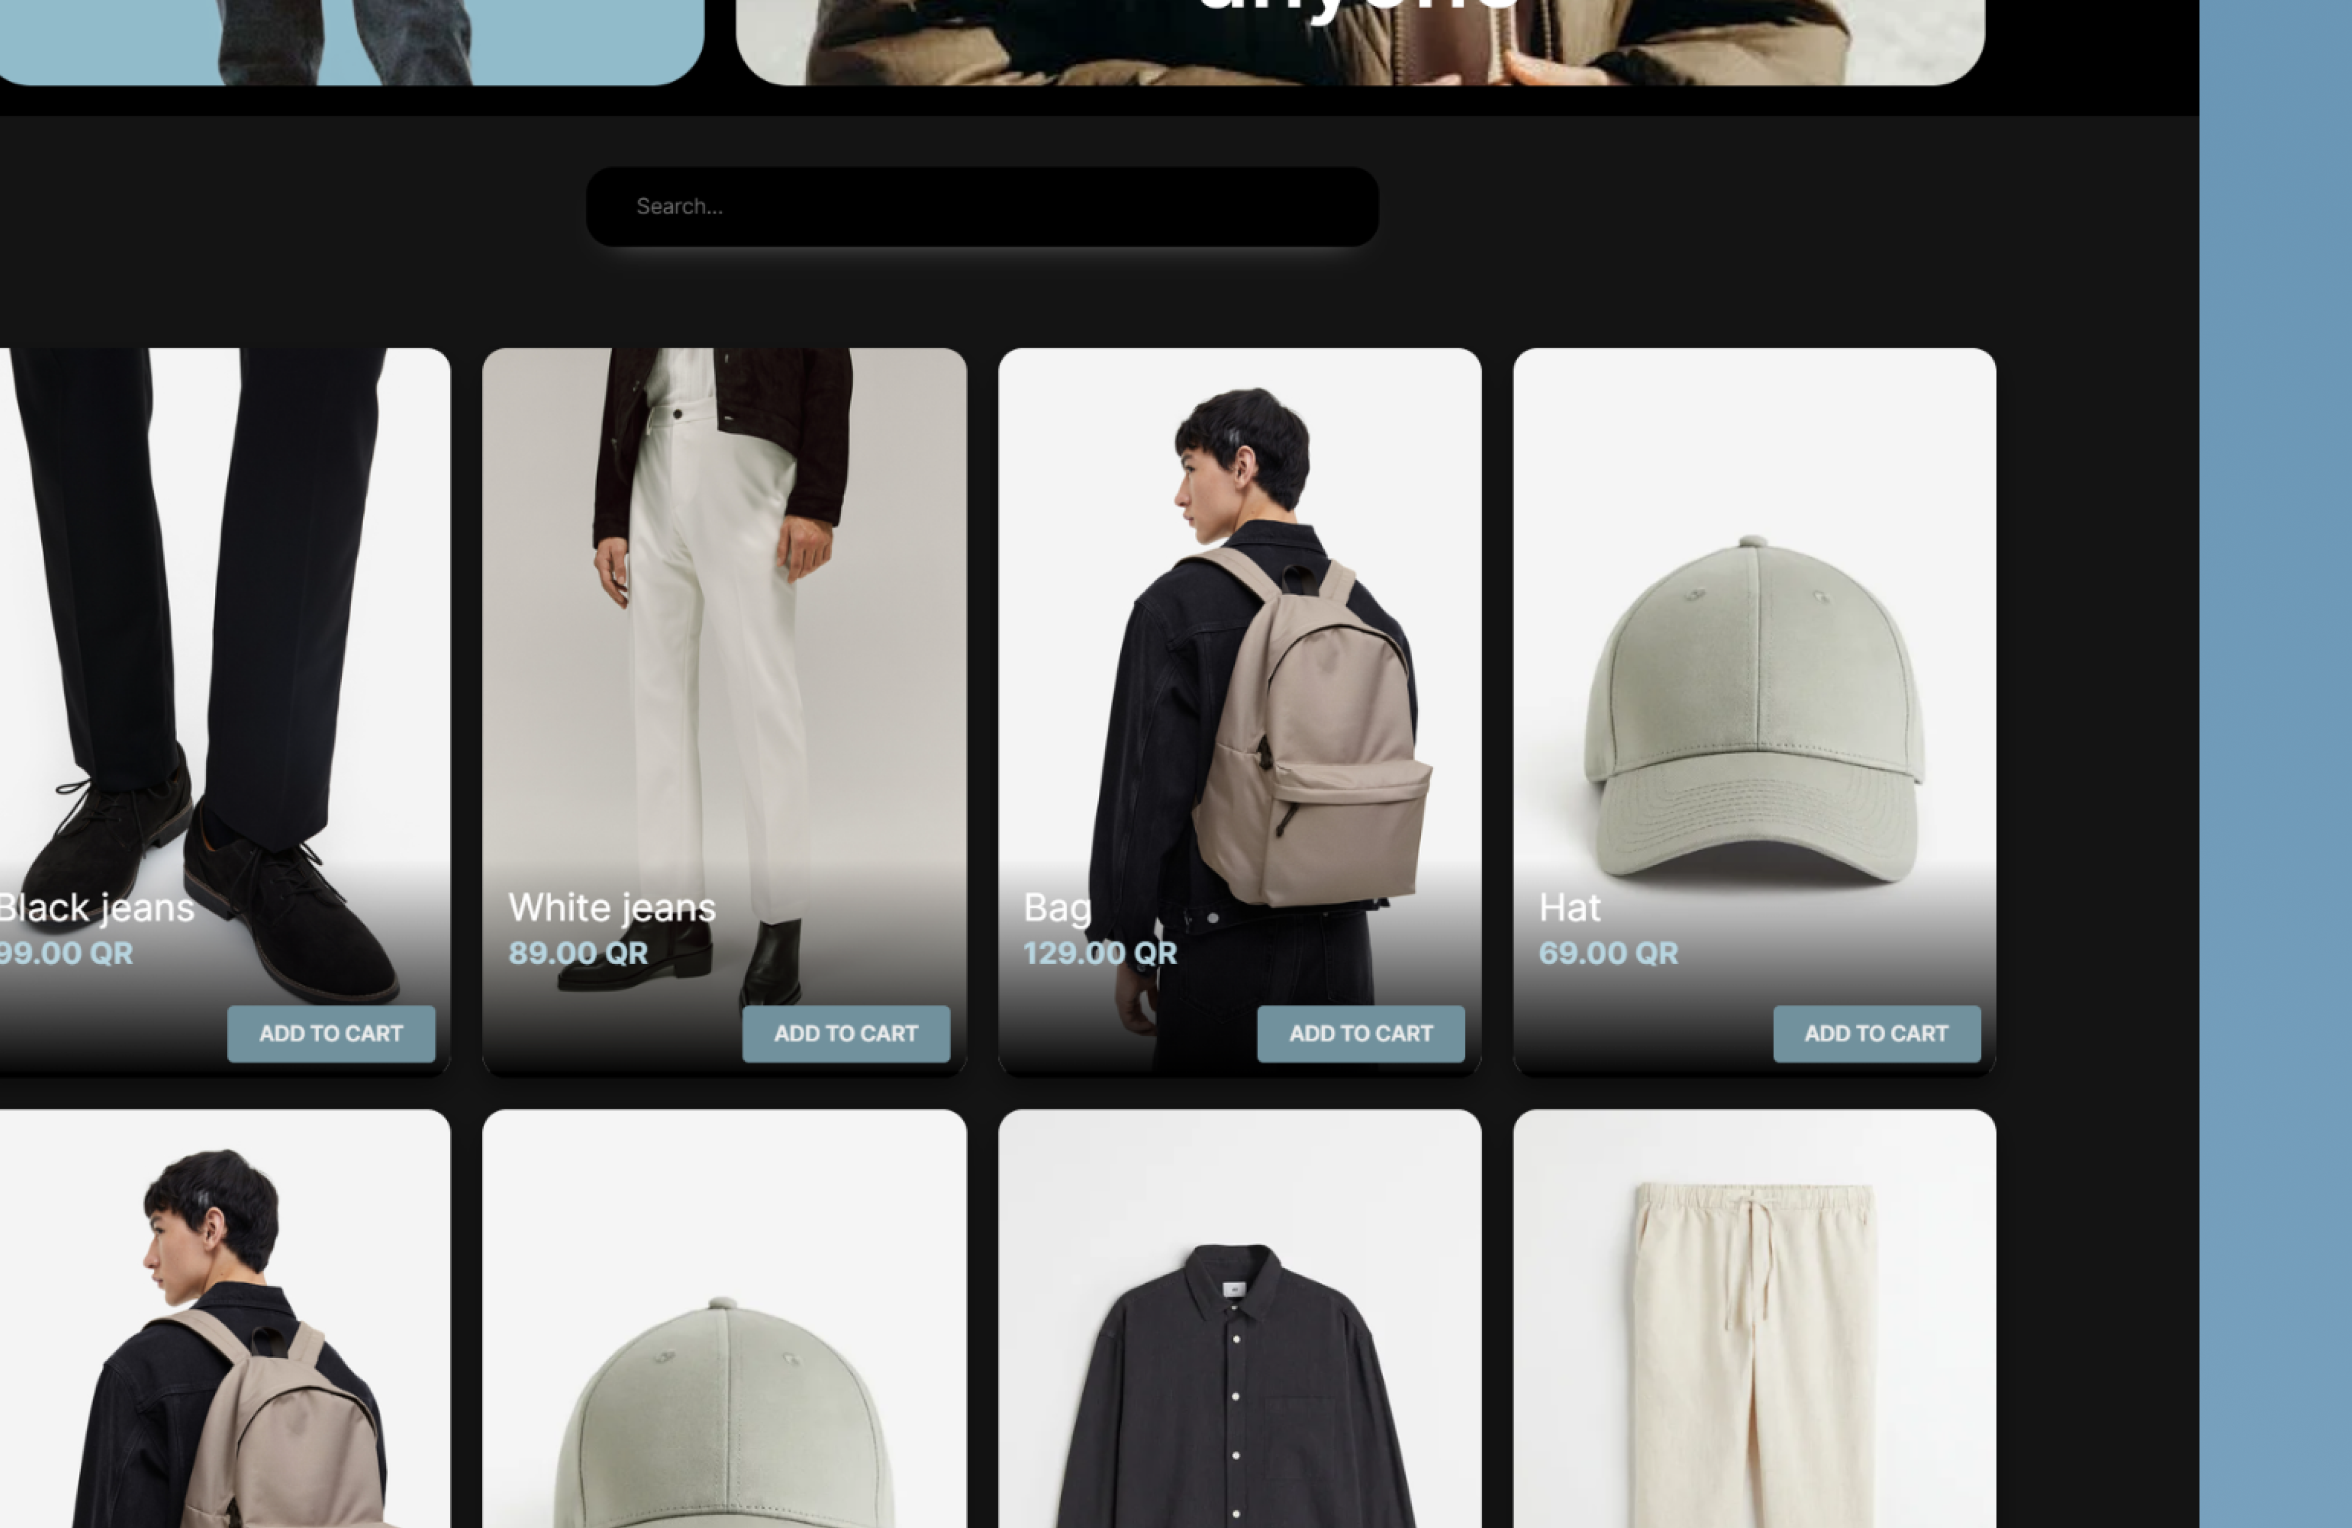

This screenshot is from the available products section in the main page where customers can purchase items.